# Employee Performance and Attrition Report

- Sayan Das

## 1. Data Extraction: Loading CSV Files into Pandas

I began by extracting the data from the provided CSV files. The project involved three datasets: - **Employee Data:** Contains personal and job-related details. - **Attrition Data:** Contains attrition flags and exit interview scores. - **Employee Performance Data:** Contains performance ratings, training hours, and other performance metrics.

I loaded each CSV into a Pandas DataFrame and ensured that the lower-case gender column was removed so that only the Gender column was used. Here is the code I used:

# Read CSV files

employee_df = pd.read_csv('employee_data 1.csv')

attrition_df = pd.read_csv('Attrition 1.csv')

performance_df = pd.read_csv('employee_performance_data 1.csv')

# Display initial shapes

print("Employee Data Shape:", employee_df.shape)

print("Attrition Data Shape:", attrition_df.shape)

print("Performance Data Shape:", performance_df.shape)

# Drop lower-case 'gender' column if it exists; keep only the 'Gender' column.

if 'gender' in employee_df.columns:

    employee_df = employee_df.drop(columns=['gender'])

print("Columns in employee_df after dropping 'gender':", employee_df.columns.tolist())

## 2. Data Transformation & Cleaning

After loading the data, I validated the uniqueness of the primary key (Employee_ID) in each dataset to ensure data integrity.

# Check uniqueness in employee data

if employee_df['Employee_ID'].is_unique:

    print("Employee_ID is unique in employee_data.")

else:

    print("Employee_ID has duplicates in employee_data.")

# Standardize column name in attrition data and check uniqueness

attrition_df.rename(columns={'employee_ID': 'Employee_ID'}, inplace=True)

if attrition_df['Employee_ID'].is_unique:

    print("Employee_ID is unique in attrition_data.")

else:

    print("Employee_ID has duplicates in attrition_data.")

# Check uniqueness in performance data

if performance_df['Employee_ID'].is_unique:

    print("Employee_ID is unique in performance_data.")

else:

    print("Employee_ID has duplicates in performance_data.")

I then merged the datasets: - I performed an inner join between employee_df and performance_df on Employee_ID to capture only the employees with available performance data. - I then left-joined the resulting DataFrame with attrition_df on Employee_ID.

**Since the project required only complete records, I removed any rows that had missing values in either the attrition or Exit_Interview_Score columns**.

**Just because I don't have the data do not mean that those employee havn’t left the company.**

# Merge employee and performance data on Employee_ID (inner join)

emp_perf_df = pd.merge(employee_df, performance_df, on='Employee_ID', how='inner')

print("Shape after merging employee and performance data:", emp_perf_df.shape)

# Merge with attrition data (left join)

full_df = pd.merge(emp_perf_df, attrition_df, on='Employee_ID', how='left')

print("Shape before dropping incomplete records:", full_df.shape)

# Drop rows with missing values for 'attrition' or 'Exit_Interview_Score'

full_df = full_df.dropna(subset=['attrition', 'Exit_Interview_Score'])

print("Shape after dropping rows with missing attrition or exit interview score:", full_df.shape)

I also merged the first_name and last_name columns into a single name column in the employee dimension later in the process.

## 3. Creating Fact and Dimension Tables (Star Schema)

I then transformed the cleaned DataFrame into a star schema by creating one fact table and several dimension tables.

### Fact Table: fact_employee_performance

This table captures performance metrics along with attrition and exit interview scores. It also includes surrogate key references for departments and job roles.

fact_table = full_df[['Employee_ID', 'Performance_Rating', 'Last_Promotion_Year',

                        'Training_Hours', 'Work_Life_Balance', 'Job_Satisfaction',

                        'attrition', 'Exit_Interview_Score']].copy()

### Dimension Tables

#### Employee Dimension (dim_employee)

I excluded Department and Job_Role from this dimension, and I merged first_name and last_name into a new name column.

# Create Employee Dimension (exclude department and job role)

dim_employee = full_df[['Employee_ID', 'Age', 'first_name', 'last_name', 'Gender',

                          'Education_Level', 'Marital_Status', 'Job_Tenure', 'Distance_From_Home']].drop_duplicates()

# Merge first and last names into a single column 'name'

dim_employee['Name'] = dim_employee['first_name'] + ' ' + dim_employee['last_name']

dim_employee = dim_employee.drop(columns=['first_name', 'last_name'])

#### Department Dimension (dim_department)

I created a table containing unique departments and added a surrogate key:

dim_department = full_df[['Department']].drop_duplicates().reset_index(drop=True)

dim_department['Department_ID'] = dim_department.index + 1

print("Department Dimension Shape:", dim_department.shape)

#### Role Dimension (dim_role)

Similarly, I created a role dimension table:

dim_role = full_df[['Job_Role']].drop_duplicates().reset_index(drop=True)

dim_role['Role_ID'] = dim_role.index + 1

Next, I merged the department and role information into the fact table to reference their surrogate keys:

# First, add the original department and job role columns to fact table for the lookup.

fact_table = pd.merge(fact_table, full_df[['Employee_ID', 'Department', 'Job_Role']], on='Employee_ID', how='left')

# Merge department ID from dim_department

fact_table = pd.merge(fact_table, dim_department, on='Department', how='left')

# Merge role ID from dim_role

fact_table = pd.merge(fact_table, dim_role, on='Job_Role', how='left')

# Remove redundant text columns (Department and Job_Role) after merging IDs

fact_table.drop(columns=['Department', 'Job_Role'], inplace=True)

print("Fact Table Shape:", fact_table.shape)

## 4. Removing Duplicate Employee_ID Records

Although I ensured data integrity during transformation, I also implemented a method to remove duplicate Employee_ID records directly from the fact_employee_performance table.

### In SQL:

After loading the transformed data into MySQL, I used the following SQL code to remove any duplicate records from the fact_employee_performance table. To work around MySQL safe update mode, I disabled safe updates for the session:

-- Disable safe update mode for this session  
SET SQL_SAFE_UPDATES = 0;  
  
-- Add a temporary auto-increment primary key column  
ALTER TABLE fact_employee_performance   
ADD COLUMN temp_id INT AUTO_INCREMENT PRIMARY KEY;  
  
-- Delete duplicate rows, keeping the row with the smallest temp_id for each Employee_ID  
DELETE f1   
FROM fact_employee_performance f1  
INNER JOIN fact_employee_performance f2   
 ON f1.Employee_ID = f2.Employee_ID   
 AND f1.temp_id > f2.temp_id;  
  
-- Remove the temporary column  
ALTER TABLE fact_employee_performance   
DROP COLUMN temp_id;

This SQL code ensures that only one record per Employee_ID remains in the fact table.

## 5. Loading Transformed Data into MySQL

I used SQLAlchemy to connect to the MySQL database and loaded the fact and dimension tables into their respective tables. Here is the code snippet:

**from sqlalchemy import create_engine**  
# MySQL connection details  
username = 'root'

password = '12345'

host = 'localhost'

port = '3306'

database = 'case3'

engine = create_engine(f'mysql+pymysql://{username}:{password}@{host}:{port}/{database}')  
  
# Load tables into MySQL

fact_table.to_sql('fact_employee_performance', con=engine, if_exists='replace', index=False)

dim_employee.to_sql('dim_employee', con=engine, if_exists='replace', index=False)

dim_department.to_sql('dim_department', con=engine, if_exists='replace', index=False)

dim_role.to_sql('dim_role', con=engine, if_exists='replace', index=False)

print("Data loaded to MySQL successfully.")

## 6. KPI Tracking & Monitoring

* **DAX measures**
  + **Attrition Rate:**

Attrition Rate =

DIVIDE(

CALCULATE(COUNTROWS(fact_employee_performance), fact_employee_performance[attrition] = TRUE),

COUNTROWS(fact_employee_performance)

)

* + **Retention Rate:**

Retention Rate = 1 - [Attrition Rate]

* + **Average Tenure:**

Average Tenure = AVERAGE(dim_employee[Job_Tenure])

* + **Department-wise Employee Score:**

Average Employee Satisfaction = AVERAGE(fact_employee_performance[Job_Satisfaction])

* + **Average Performance Rating:**

Average Performance Rating = AVERAGE(fact_employee_performance[Performance_Rating])

* + **Average Exit Interview Satisfaction Score:**

Average Exit Interview Score = AVERAGE(fact_employee_performance[Exit_Interview_Score])

* + **Department-wise Attrition Rate:**

Dept Attrition Rate =

DIVIDE(

CALCULATE(COUNTROWS(fact_employee_performance), fact_employee_performance[attrition] = TRUE),

COUNTROWS(fact_employee_performance)

)

* Employee Satisfaction Score:

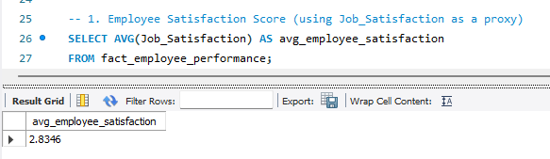

* Average Tenure:

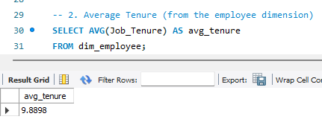

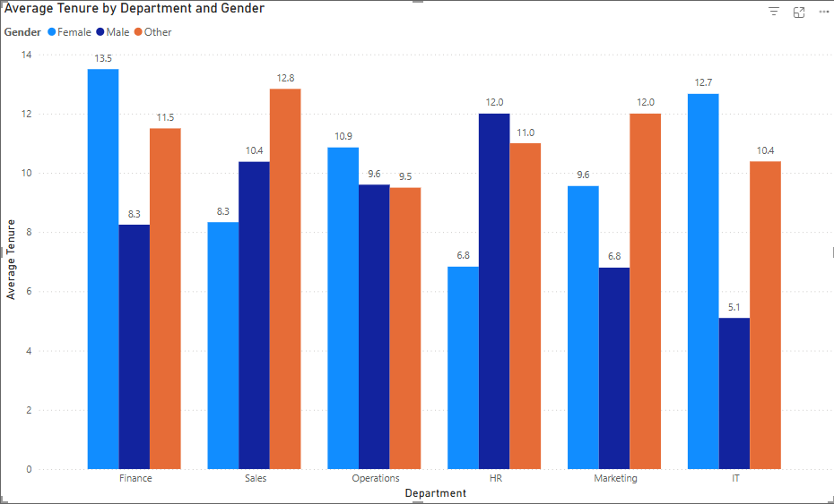

* Attrition Rate:

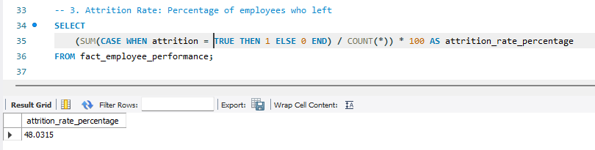

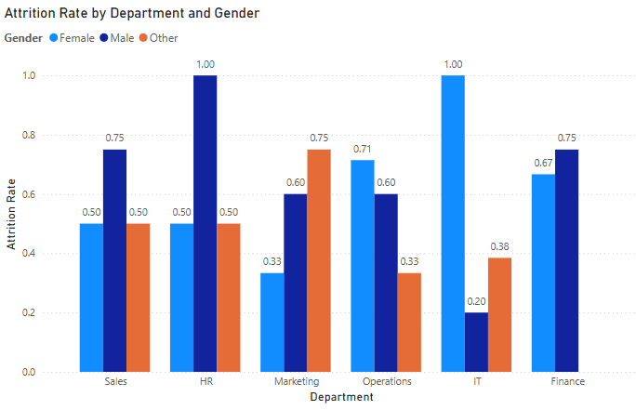

* Performance Rating Distribution:

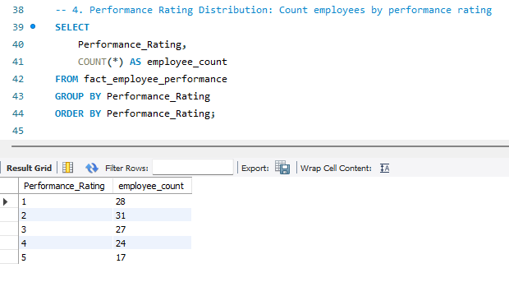

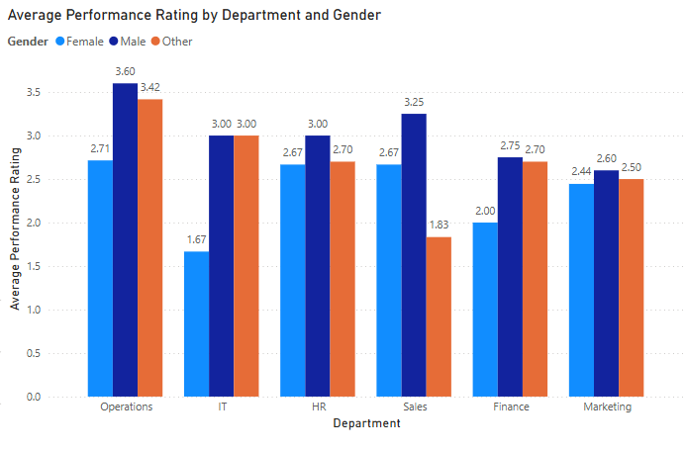

* Department-wise Attrition Trends:

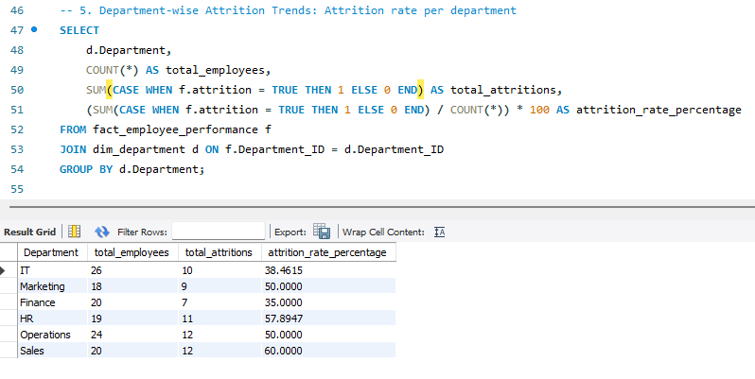

* Exit Interview Sentiment Analysis:

Given below are average Exit_Interview_Score per department. I cannot do Text analysis because there is no text/transcript to analyse.

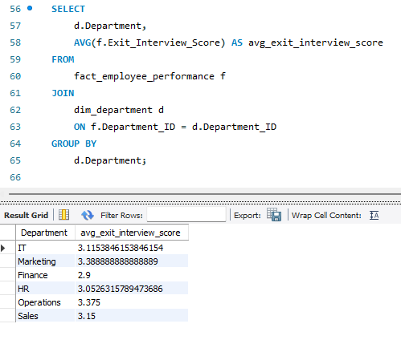

* Attrition Rate, Retention Rate, Average Tenure, Average Performance Rating, Average Performance Rating

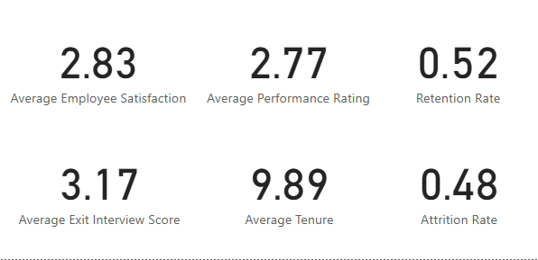

* Department-wise Employee Score – I assumed performance rating is same as employee code.

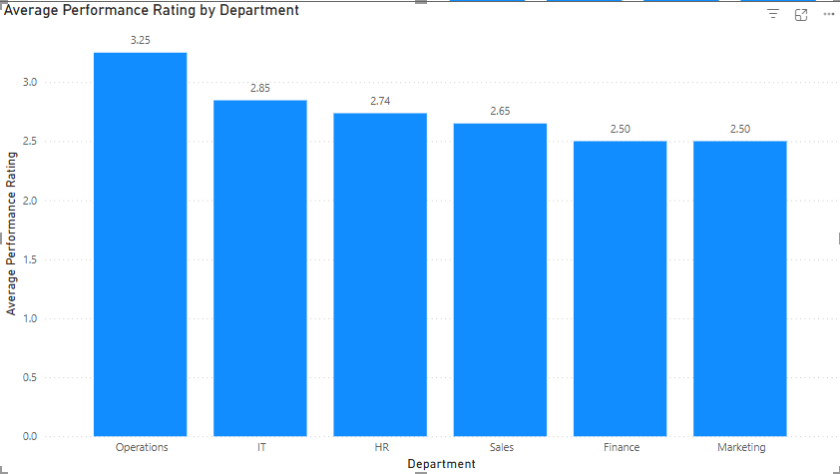

* Department wise Attrition Rate

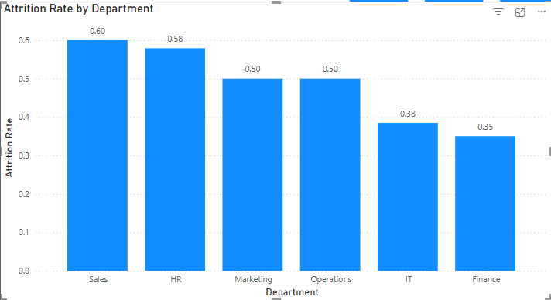

* Overall

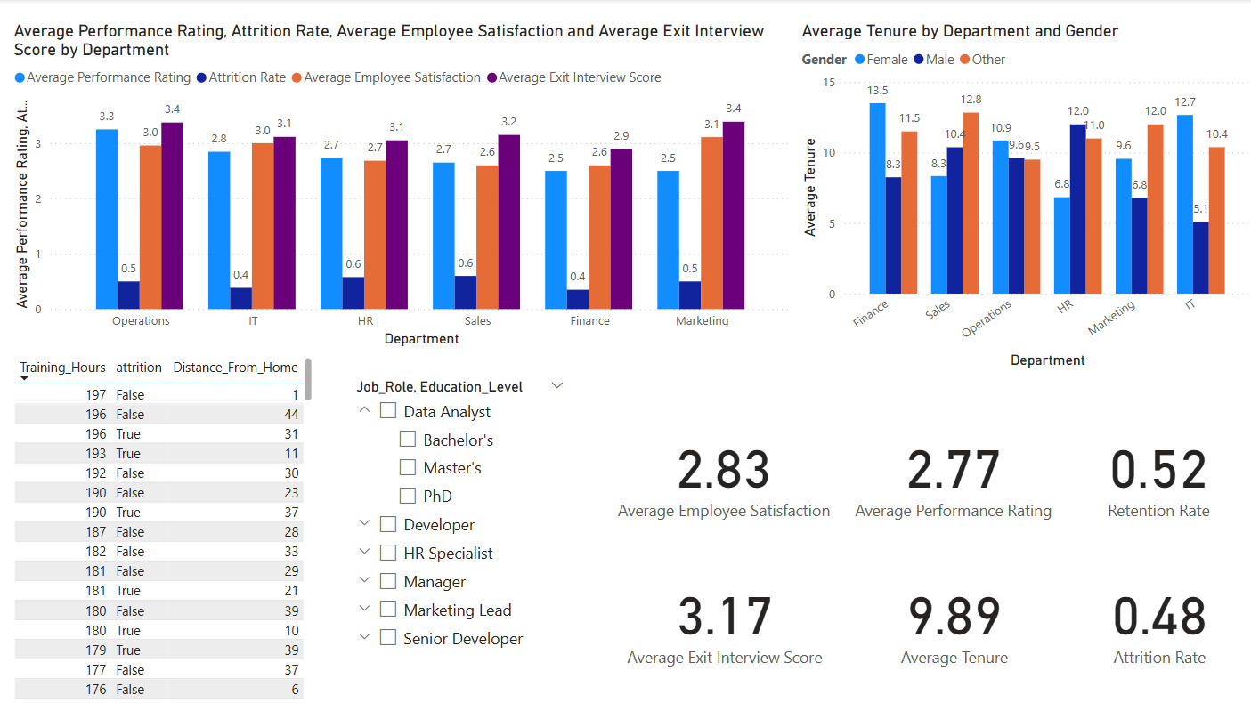

## 7. Conclusion

**Department-Level Observations:**

* **HR** appears to have the **highest performance rating** and **highest employee satisfaction** among departments. Correspondingly, it shows a **lower attrition rate** and relatively higher exit interview scores.
  + **Interpretation**: HR’s strong performance and job satisfaction likely contribute to reduced turnover.
* **Marketing** exhibits the **highest attrition rate** alongside the **lowest satisfaction** and **lowest exit interview scores**.
  + **Interpretation**: High turnover may be tied to lower satisfaction; it suggests a need for deeper investigation into work conditions, role expectations, or leadership in Marketing.
* **IT** and **Finance** fall somewhere in the middle, with moderate performance ratings and satisfaction. However, Finance’s attrition rate is somewhat high, indicating room for improvement.
* **Operations** has moderately high attrition but not as severe as Marketing, suggesting some departmental-specific issues.

**Average Tenure Differences:**

* **HR** employees tend to have **longer average tenure**, suggesting higher retention and possibly better internal mobility or more favorable work conditions.
* **Marketing** tends to show **shorter average tenure**, aligning with the higher attrition rate. This could point to burnout, role dissatisfaction, or a mismatch in job expectations.

**Overall Company Metrics:**

* **Average Employee Satisfaction** is around **2.83** (on the scale shown). This is neither very high nor extremely low, but it does leave room for improvement.
* **Average Performance Rating** is **2.77**, indicating that most employees are performing moderately. Departments like HR stand out with slightly higher averages, while Marketing and Finance might need targeted performance management interventions.
* **Average Exit Interview Score** is **2.52**, which suggests that employees who do leave have mixed feelings. Departments with particularly low scores (like Marketing) should investigate root causes—possibly leadership issues, workload concerns, or career development opportunities.
* **Attrition Rate** of **0.48** (48%) is notably high. This signals that nearly half of the workforce observed may be leaving in the measured period. Reducing attrition, especially in high-turnover departments, should be a top priority.
* **Average Tenure** is around **9.89 years**, which is reasonably long overall, but it likely skews higher in departments like HR and lower in Marketing.

**Actionable Insights & Recommendations:**

* **Focus on Marketing**: With the highest attrition rate and lowest satisfaction, it’s crucial to investigate whether employees have clear career paths, sufficient resources, and supportive management.
* **Boost Overall Satisfaction**: Since satisfaction correlates with lower attrition, HR interventions—like flexible schedules, better recognition, and clearer promotion paths—could improve retention.
* **Continue HR Best Practices**: The HR department’s relatively high satisfaction and lower attrition can be used as a case study for best practices—potentially replicating them in other departments.